User Interface Usability Design

Student’s Name
Institutional Affiliation
Course
Professor
Date

Table of Contents
Table of Contents 2
Introduction 3
Project Outline 3
Functional Options to be Included/ City Description 3
Physical Description of Display 4
Input Tools Interaction 4
Screen 4
Smart Phone 5
How it Supports People with Disability 6
User Interface Design Prototypes 7
Kiosk Display Prototype 7
Smart Phone Mock-Up 9
Usability Test Questionnaire 11
Usability Test Instruction Guide 11
Usability Test Results Final 11
References 12

Introduction

Project Outline
The city that is selected for the Kiosk is Panama in Florida, and it will be situated at major shopping centers and supermarkets, to enable each visitor to have access. Through these kiosks, the visitors will be able to have access to all the restaurants, recreation centers, as well as other attraction sites in the area. This will be helpful in terms of saving time as visitors waste a lot of time as they try to find out where they want to go.

Functional Options to be Included/ City Description
The city of Panama is one of the most attractive tourist sites in Florida. Although Florida residents can choose other cities over Panama, tourists usually prefer it due to its 27 miles stretch of white beaches, making it attractive for weekends. It makes one of the most enjoyable places for group reunion. Some of the services available to visitors when they visit Panama City beach is whale watching, jet skiing. The city has many hotels, which can be selected to preference of the visitor. The tourist kiosk will offer all this information and they can select and navigate through the kiosk application until they find a preferred destination in Panama.
The Panama tourist kiosk will offer diverse information, and they can locate information regarding parks, events, restaurants, casinos, and other recreation sites within the City of Panama. The kiosk will also have an application designed for smart phones to make it easy to access the information via their smart phones. This will be important to decongest the kiosk and allow for smooth facilitation of tourists with information they need whenever they are during their visit in Panama. Using the kiosk will improve time efficiency and ensure the information is accessible within a short period of time (Lazar & Barbosa, 2017).

Physical Description of Display
The Kiosk will be made up of a 22-inch size LCD screen, which will be high gloss to make it possible to display diverse colors. There will be a 3-inch panel around the monitor, and will have a keyboard, a touch screen, voice control, and a printer. It will have a speaker at the top of the monitor and a data transfer ports to make it easier for the user to transfer date to their phones. The monitor will be lock to wall, with fans near the power supply to prevent overheating.
Smart phone users, they will need to have an android phone or an iPhone, with support to voice control. The smart phone will also give a touch screen, internet connectivity via 4G, 5G or via the Wi-Fi support. It must also have a screen keyboard and audio player (Lazar & Barbosa, 2017).
The kiosk will be designed such that both standing and people using wheelchair can easily access the screen at their convenience without struggling. The wheelchair users will not struggle because it will be designed and will have a considerable height. The text on the screen will be considerably large but the user can zoom and out to their preference to accommodate people with visual impairments so that they can see the message clearly.

Input Tools Interaction

Screen
The screen will be designed that that it will detect an incoming user and send a welcome voice message. The screen then will display user navigation information, and if they are stay for a minute without navigating, a message will display requesting them if they want to continue or to end the interaction. After that the screen will refresh waiting for a new user. A thank you message will display and wishing the user to have fin in their stay in Panama.
In case the user wants to continue using the screening he will be required to input the continue command. Then the screen will display different languages and they will select their preferred language. The main languages they will find in the Kiosk include English, Spanish, Chinese, German, Japanese, and French. Then the main menu will display asking the user where they want to go, or the specific information that they would like to know. Various buttons will display to help the user navigate easily. After use, they will input the exit button for the next user.
Once the main menu appears a list of information will appear requiring the user to select their preferred service. The list will include Events, transport, restaurants, and beaches. The user will make their choice and interact with the screen to select their most preferred destination or services they would prefer. If the user would like access the menu, they will just click the exit button after which the main menu will reappear.
If a user wants to make a reservation in a hotel or a restaurant, they will select the restaurant from the list; a dialogue box will appear directing the user to input their preferred service including accommodation, food menus, and other related services. Once the user select the hotel of their choice, another dialogue box appears requiring them to type in their information. The user can select their preferred time and date to report to the hotel after which they will select reserve, and the room or service they have selected will be reserved on the indicated time in the hotel system.

Smart Phone
For a smart phone to support the application it will be required to possess the following features:
- The application will support either an android or an iPhone.
- Have internet support for 4G, 5G or Wi-Fi connectivity.
- Have a GPS support system so that it can access the map to nearby places.
- The user will easily interact with the screen if the above features are present after they connect via the Kiosk application. However, to use the service they must install; the kiosk application first. The application will be compatible to all devices provided they are android or iOS.
- The user can easily scroll down the drop down menu to use the application and access any service of their choice.
The smart will be similar to the Kiosk and only difference will be the size of the screen. However, all the other functionalities including the language selection, tourist choice scree will be available and they can navigate until they find their preferred service or destination.

How it Supports People with Disability
For people who are visually impaired, the kiosk will provide a voice support that allows them to navigate through the entire program. Besides, the kiosk will have an audio playback in case the user did not get the specific information they were looking. It will have a zooming option for the screen in case a person is not able to read small letters.
If the person has a hearing impairment, a person will be supported through the use of hearing aid via software if compatible. By so doing, any command input will be displayed on the screen and they can easily navigate through the text display which they can easily read and select information that suits their preferences. This category will also be supported by texts, images, and buttons that they easily use when navigating the screen.
If an individual is physically impaired, the product will have an option for voice command interaction where the user can use a mic to navigate through the screen. Voice search will also be available for this category of users (Lazar & Barbosa, 2017).

User Interface Design Prototypes

Kiosk Display Prototype
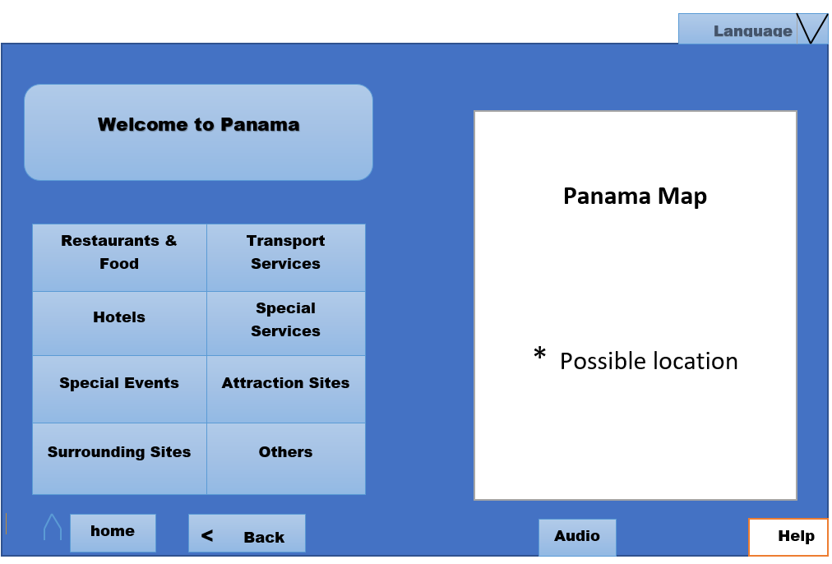
The above is the mock-up display for the home screen of the Panama Tourist Kiosk. This mock up is to display the features of the kiosk and they will be used. On touching the screen, buttons will appear on the screen including the home button, back, help and language. From the above diagram these buttons will help the user navigate through the home screen and select where they want to go. The home bottom helps the user to go back to the main screen. However, if the home screen is clicked when on the home screen, it will turn to sleep mode and will end the session. If the user clicks on the back button, they will be taken back to the previous screen. When the user clicks the audio button, they will be able to adjust the volume and either play or stop the sound play. The speaker is installed to enable those with hearing impairments and the visually impaired by converting the audio to written format and written to audio. The help button will be used by the user to seek assistance on navigating, such as when they want to control the output.
At the top right corner, there is the language button and the exit button. Once the user clicks the language button, all the language will be displayed in the drop down menu, and they can select their preferred language. The first step when using the kiosk will be to select the preferred language, after which everything else on the screen will be displayed. When the user clicks on the exit button, the current session will end, and the user will be returned to the home screen, after which the session will be ended. However, before the session ends, they will be asked to confirm if they want to terminate their interaction through a dialogue box.
At the center of the main screen is list of items that a user would like to use. The screen displays 8 items, and where they would like to go based on the location of the kiosk. The user will have the freedom to zoom in and out and see finer details within the maps and the locations they would like to visit. The user can then click on the screen on the item they would like. If they want a restaurant, they will just click on the box with the restaurant. After they click on the page, a new page will appear and presents options of restaurants from which they can select their most preferred.
Panama Tourist Kiosk will offer great experience to the user by availing information without having much struggle that they could have experienced when such kiosks are not available in the City of Panama. The kiosk operates on the normal screen as that of a touch screen phone, thus it is user friendly and easy to use. However, if a user has never had an experience with the touch screen, they will be able to use the help button and they will access guidance either over written text or through audio for those with visual impairments. This makes it simple to navigate through the screen and access whatever service they would like to access.

Smart Phone Mock-Up
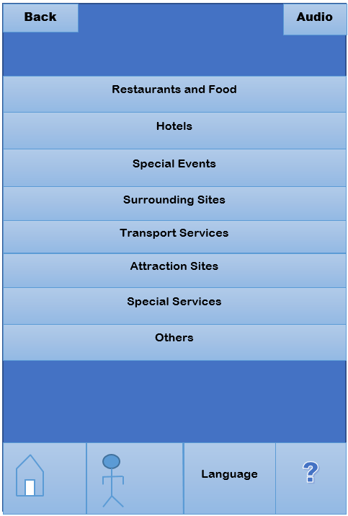
The above is a mock diagram of the Panama Tourist Kiosk smart phone application. The application will work in both android and iOS phones, with different screen sizes. The top of the screen will a back and an audio button. The back button will be used by the user to move back to the previous screen, and when they go back to the main scree, the user session will be ended. The audio button will be used by the user to play the text message in audio format. The user will be able to regulate the volume using their phone’s volume button.
In the middle of the smart phone screen is a list of eight options that the user, and if he chooses one of the options, then a new screen displays. The new screen will avail all the details regarding that specific option. If a user selects option under the special events, all the information regarding the special events in the City of Panama will display on the screen. The user can navigate through the screen until they find their preferred.
At the bottom of the smart phone screen are four buttons that can assist the user on whatever navigation they would like to make. The search button will help the user type in any information they want to find on the map. The smart is GPS enabled and the user can search any location in Panama. Besides, the user can navigate the through the screen, using the home button to return to the home screen if they want to end their session. They can also select the language they want to use. Besides, they can also seek assistance using the help button.
The user experience through the smart application compliments the kiosk and the user can access any service that they can find in the Kiosk. In addition, the application is compatible with any screen size so that the user will not struggle trying to fit information of the screen as they try to navigate. The visually impaired can use the application because it has a sound enhancer, which can convert a text to sound.

Usability Test Questionnaire

Usability Test Instruction Guide

Usability Test Results Final

References
Lazar, J., & Barbosa, S. D. (2017, May). Introduction to human-computer interaction. In Proceedings of the 2017 CHI Conference Extended Abstracts on Human Factors in Computing Systems (pp. 1202-1204).

